# Experiment No 04: Discrete Correlation

CLASS: BE CMPN A ROLL NO. : 19

Name: Rebecca Dias Pid: 182027

**Aim :** To perform the correlation operation of two discrete signals in Python

# Theory :

Correlation is used to compare two signals. It is a measure of similarity between signals.It occupies a significant role in signal processing.The correlation is of two types: (i) Cross correlation (ii) Auto-correlation.

# Cross correlation

The cross correlation between a pair of sequences x(n) and y(n) is given by

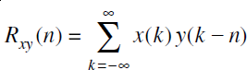

The expression for Rxy(n) can be written as:



# Auto-correlation

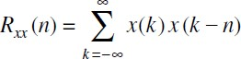The autocorrelation of a sequence is correlation of a sequence with itself. It gives a measure of similarity between a sequence and its shifted version. The autocorrelation of a sequence x(n) is defined as:

It is given by



# Programming Exercises in Python

1. Determine the correlation of the following signals x(n) = {1,2,3,4} and h(n) = {4,3,2,1}

Code:

|  |
| --- |
| x=[1,2,3,4]  h=[4,3,2,1]  import numpy as np  import matplotlib.pyplot as plt  h=h[::-1]  print("h(-n)= ",h)  x1=np.array(x)  h1=np.array(h)  sum=np.correlate(x1,h1,"full")  print("Final Signal", sum)  mat=[[],[],[],[]]  index=0  for i in x:    for j in h:      res = i * j      mat[index].append(res)    index += 1    m = '\n'.join([''.join(['{:4}'.format(item) for item in row]) for row in mat])  print("The matrix is: \n")  print(m)  y=np.array(sum)  x1=np.arange(0,7,1)  plt.title('Q1')  plt.xlabel('x(n)')  plt.ylabel('y')  plt.axvline(0,0,color='black')  plt.stem(x1,y,use_line_collection=True)  plt.show() |

Output:

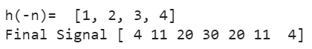

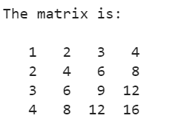

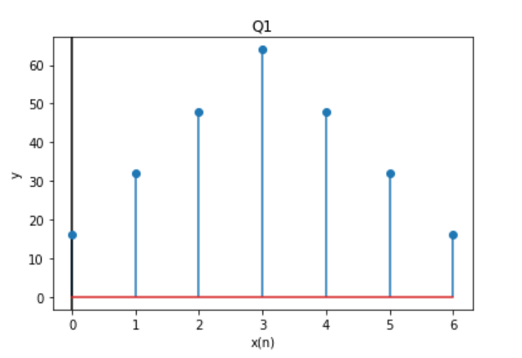

1. Determine the auto-correlation of the following signal x(n) = {4,4,4,4}

|  |
| --- |
| a=[4,4,4,4]  ainv=a[::-1]  a1=np.array(a)  ainv1=np.array(ainv)  sum=np.correlate(a,ainv,"full")  print("The final signal is", sum)  mat=[[],[],[],[]]  index=0  for i in a:    for j in ainv:      res = i * j      mat[index].append(res)    index += 1    m = '\n'.join([''.join(['{:4}'.format(item) for item in row]) for row in mat])  print("The matrix is: \n")  print(m)  y=np.array(sum)  x1=np.arange(0,7,1)  plt.title('Q2')  plt.xlabel('x(n)')  plt.ylabel('y')  plt.axvline(0,0,color='black')  plt.stem(x1,y,use_line_collection=True)  plt.show() |

Output:



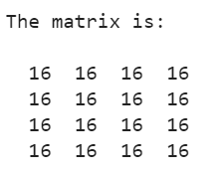

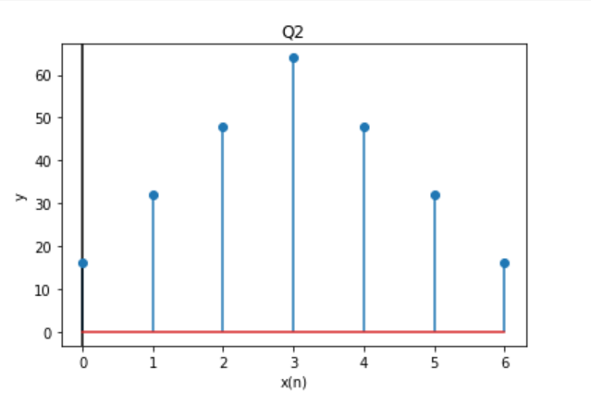

**Conclusion:**

Correlation between signals indicates the measure up to which the given signal resembles another signal. During this experiment,we implemented correlation on discrete time signals using Python.